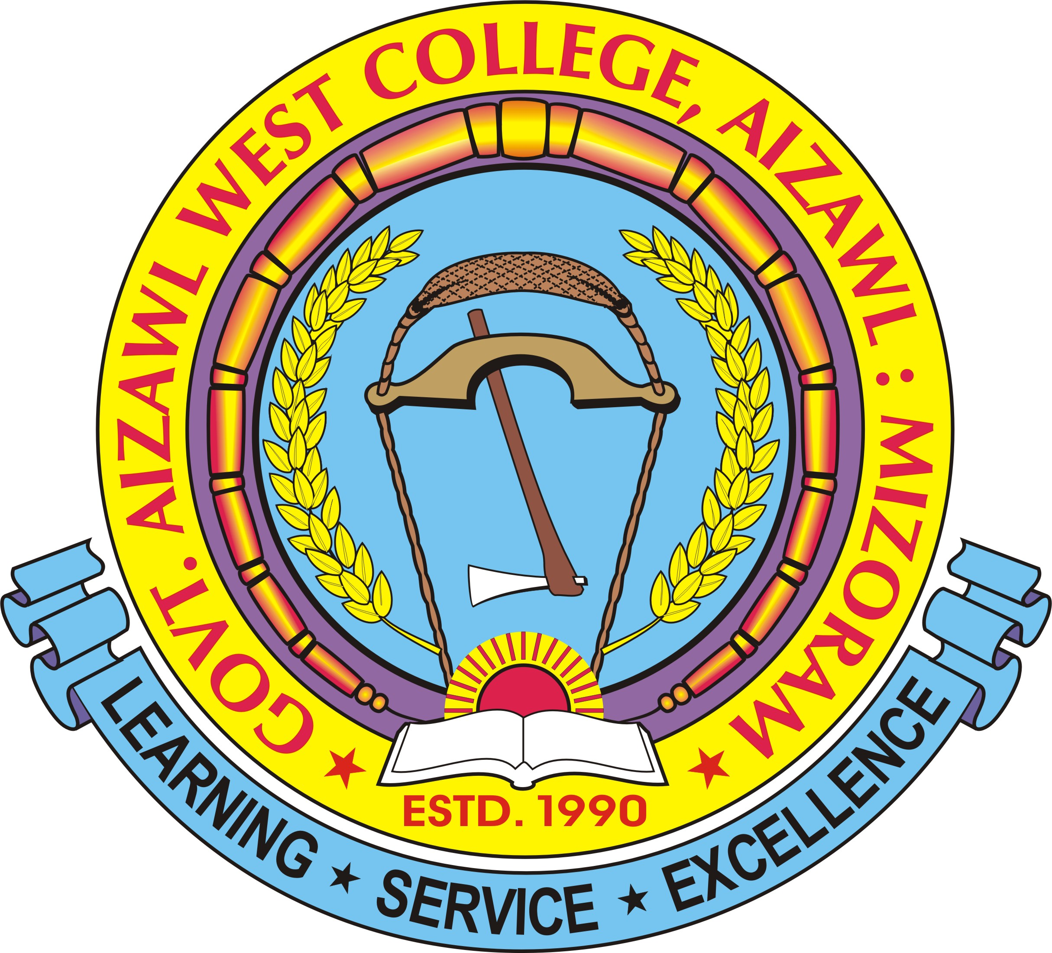
OFFICE OF THE PRINCIPAL
GOVT. AIZAWL WEST COLLEGE
GOVERNMENT OF MIZORAM
Dawrpui Vengthar, Aizawl, 796001 Ph – (0389) 2325945 (O) Fax – ( 0389 )- 2325945
No.B.18003/3/2009-GAWC/IQAC/ Dated Aizawl the 30th January, 2020

INTERNAL QUALITY ASSURANCE CELL (IQAC)
GOVT. AIZAWL WEST COLLEGE
2020

NOTICE

This is to notify that different cells under IQAC have been restructured for the year 2020-2021.
All the cells are hereby instructed to submit their respective action plan for 2020-2021 latest by 17th February, 2020(Monday) positively to the Coordinator IQAC.

- Steering Committee
Chairman : Dr. P. Lalremliana
Coordinator : Dr. Samuel V.L. Thlanga
Asst. Coordinator : Ms. Lalremruati
Members
Ms. Lianhlupuii
Dr. P.L. Ramliana
Dr. Mary Ann Lalbiakhlui Zadeng
Mr. H. Lalvulliana
Prof. Benjamin Lalrinsanga, RUSA Coordinator
Dr. Janet Vanlalhlimpuii
Ms. Lalnunthari, AISHE Coordinator
Head Assistant
Mr. Lalhmingliana
Jt. Director, H&TE Govt. of Mizoram (Management representative)
Chairman, Local Council, Dawrpui Vengthar (Local representative)
Prof. Lalnundanga, MZU
Prof. H.K. Laldinpuii Fente, MZU
Vice President, Student’s Union GAWC

- Information Technology Cell
Chairman : Mr. Lalchhuanmawia Sailo
Coordinator : Mr. V. Zothankhuma
Members
Prof. Benjamin Lalrinsanga
Mr. Lalhriata
Dr. Janet Vanlalhlimpuii
Dr. R. Lalsangpuii
Mr. H. Lalawmpuia

- Academic Interaction Cell
Chairman : Prof. C. Lalthlengliana
Coordinator : Prof. Benjamin Lalrinsanga
Members
Dr. Mary Ann Lalbiakhlui Zadeng
Dr. Lalrohlui
Dr. Lalzawnga

- Research Project & Documentation Cell
Chairman : Dr. P.L. Ramliana
Coordinator : Dr. Janet Vanlalhlimpuii
Members
Dr. R. Lalzawnga
Prof. Benjamin Lalrinsanga
Ms. Lallianzuali Varte
Dr. Lalremruati Pachuau

- Grievance Redressal Committee
Coordinator : Dr. Rosangliani
Members
Ms. Lianhlupuii
Prof. C. Lalthlengliana
Dr. Vanlalvena Hnamte
Ms. K. Lalmuanpuii
Dr. Lalremruati Pachuau
Ms. Lalrinkimi Khiangte

- Career & Placement Cell
Chairman : Ms. Vanchhingpuii
Coordinator : Ms. Lalnunthari
Members
Mr. Lalhriata
Dr. Vanlalvena Hnamte
Ms. Lalremruati Vanchhawng

- Counselling Cell
Chairman : Mr. Vanlalsawma
Coordinator : Dr. Lalrohlui
Members
Ms. Malsawmtluangi Chuauhang
Ms. Lalnunthari
Ms. Lalremruati
Dr. Lalremruati Pachuau

- Language Development Cell
Chairman : Dr. Mary Ann Lalbiakhlui Zadeng
Coordinator : Ms. Lallianzuali Varte
Members
Ms. Vanchhingpuii
Mr. Lalhriata
Mr. Lalengzauva
Ms. Jennifer Saizamliani
Ms. Phillia L. Khiangte

- Sports & Youth Activities Cell
Chairman : Dr. Vanlalvena Hnamte
Coordinator : Mr. V. Zothankhuma
Members
Mr. Lalengzauva
Ms. Jennifer Saizamliani
Ms. Lalsangpuii
- Internal Complaint Cell
Chairman : Ms. Lalrosangi
Coordinator : Ms. Jennifer Saizamliani
Members
Prof. C. Lalthlengliana
Dr. Lalrohlui
Three student’s representatives
Two Non-teaching staff
One NGO member

- Library & Information Cell
Chairman : Dr. P. Lalremliana Principal
Coordinator : Librarian
Members
All Heads of Department
Vice President, S.U.
Dr. Samuel V.L. Thlanga, Coordinator, IQAC

- Equal Opportunity Cell
Chairman : Dr. P. Lalremliana Principal
Coordinator : Ms. Lalremruati Asst. Coordinator, IQAC
Members
Dr. Samuel V.L. Thlanga Coordinator, IQAC
Dr. Vanlalvena Hnamte
Ms. Lalnunthari

- Anti-Ragging Squad
Chairman : Ms. K. Lalmuanpuii
Coordinator : Ms. Malsawmtluangi Chuauhang
Members
Mr. H. Lalvulliana
Dr. P.L. Ramliana
Dr. Janet Vanlalhlimpuii

- Mentoring Cell
Chairman : Mr. H. Lalvulliana
Coordinator : Dr. Lalremruati Pachuau
Members
Mr. Vanlalsawma
Ms. Lalremruati

- Skill Development Cell
Chairman : Ms. Lianhlupuii
Coordinator : Dr. R. Lalsangpuii
Members
Prof. Benjamin Lalrinsanga
Mr. Lianhmingthanga

- Adventure Club
Chairman : Mr. Lalengzauva
Coordinator : Mr. V. Zothankhuma

- Cultural Club
Chairman : Ms. Lalthlamuanpuii
Coordinator : Ms. Lalremruati Vanchhawng
Members
Dr. Rosangliani
Mr. Lalengzauva
Ms. Lalsangpuii

(Dr. P. LALREMLIANA)
Principal
Govt. Aizawl West College

