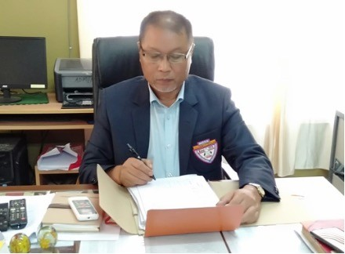

I’m glad to meet you through this page. Our College has always strived for the best in its approach to education and in its pedagogies. Over the past two years, the pandemic took us by surprise and opened up new avenues, created new environment and new conditions for learning. However, I am glad that our dedicated teachers and staff left no stone unturned to ensure that students did not lose out on quality education even when it was online or offline mode. This condition, I believed has helped the students to think out of the box and be more creative.

In the previous year, partnership was formed with Lailen Consultancy Pvt. Ltd., Aizawl to ease the administrative process enabling e-governance in the College and MS Academy, Aizawl for career and job prospects for the students. I am happy to share that this year has brought in more partnership through signing of memorandum with Patent Information Centre, Mizoram Science, Technology & Innovation Council, Government of Mizoram relating to Intellectual Property Rights; Young Mizo Association, Darlung Branch for Community Orchid Garden at Darlung Village and Govt. Middle School, Dawrpui Vengthar, to facilitate the students in learning English language. This, I hope will go a long way in enhancing the quality of education according to the objectives of the institution and serving the society at large with sensitivity and commitment.

The 2022-23 academic year envisages more research and learning. The National Education Policy, 2020 (NEP) has opened up new ventures in many fields. Apart from the normative discipline that we have been running, other certificate courses on various vocational courses will be proposed within the framework of the Policy and guidance from the experts. The College will promote both Academic and Research at all levels. To further foster interactions with prominent Academicians, we will organize many academic proceedings in the near future in collaboration with other Research Institutions.

Despite the fact that we are located in the heart of the city, the bulk of our pupils come from outlying communities. One of our top priorities is to enhance the lives of these students and I am encouraged by the progress they have made in their academics. For decades, students have been able to make use of the educational opportunities offered by the institution to identify and build upon their abilities with the prospect to learn and explore novelty in situations that present new challenges. As we start on a quest for excellence, I cordially extend an invitation to you all to join us on this adventure.



(Prof. C. LALTHLENGLIANA)

Principal

Govt. Aizawl West College