AUTOMATIC SANITARY NAPKIN VENDING MACHINE

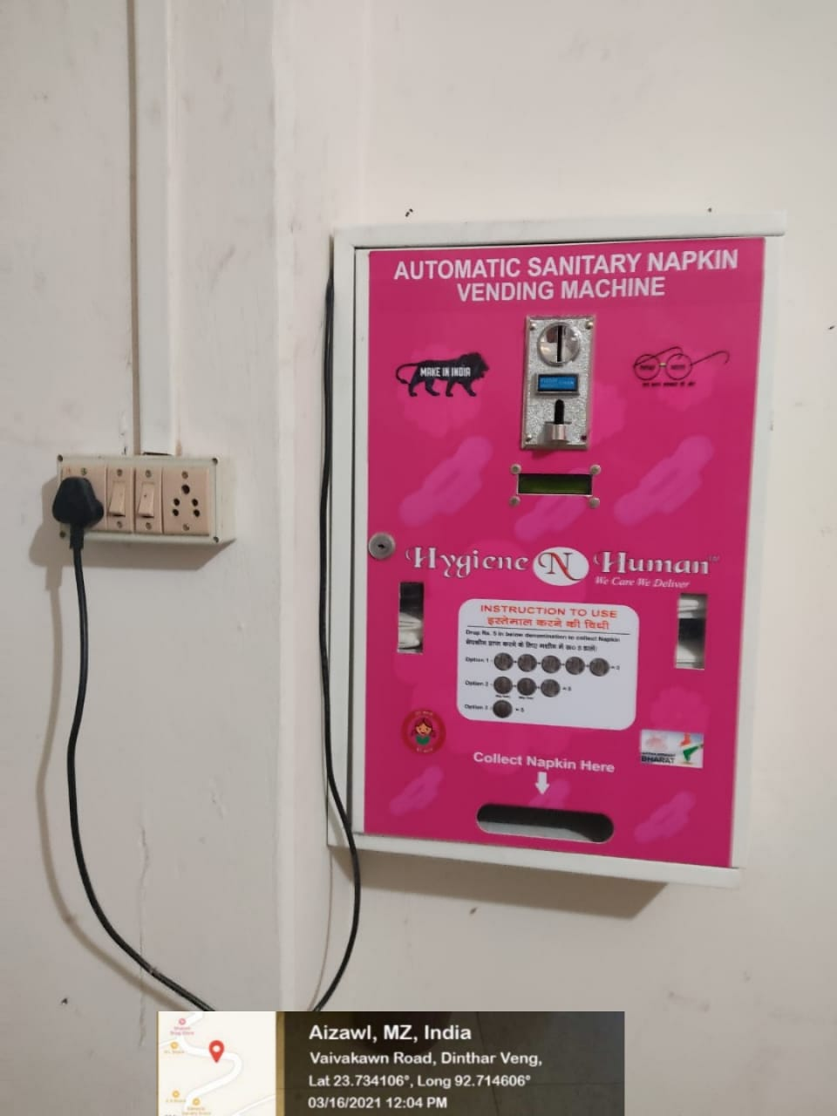

WOMEN’S REST ROOM

