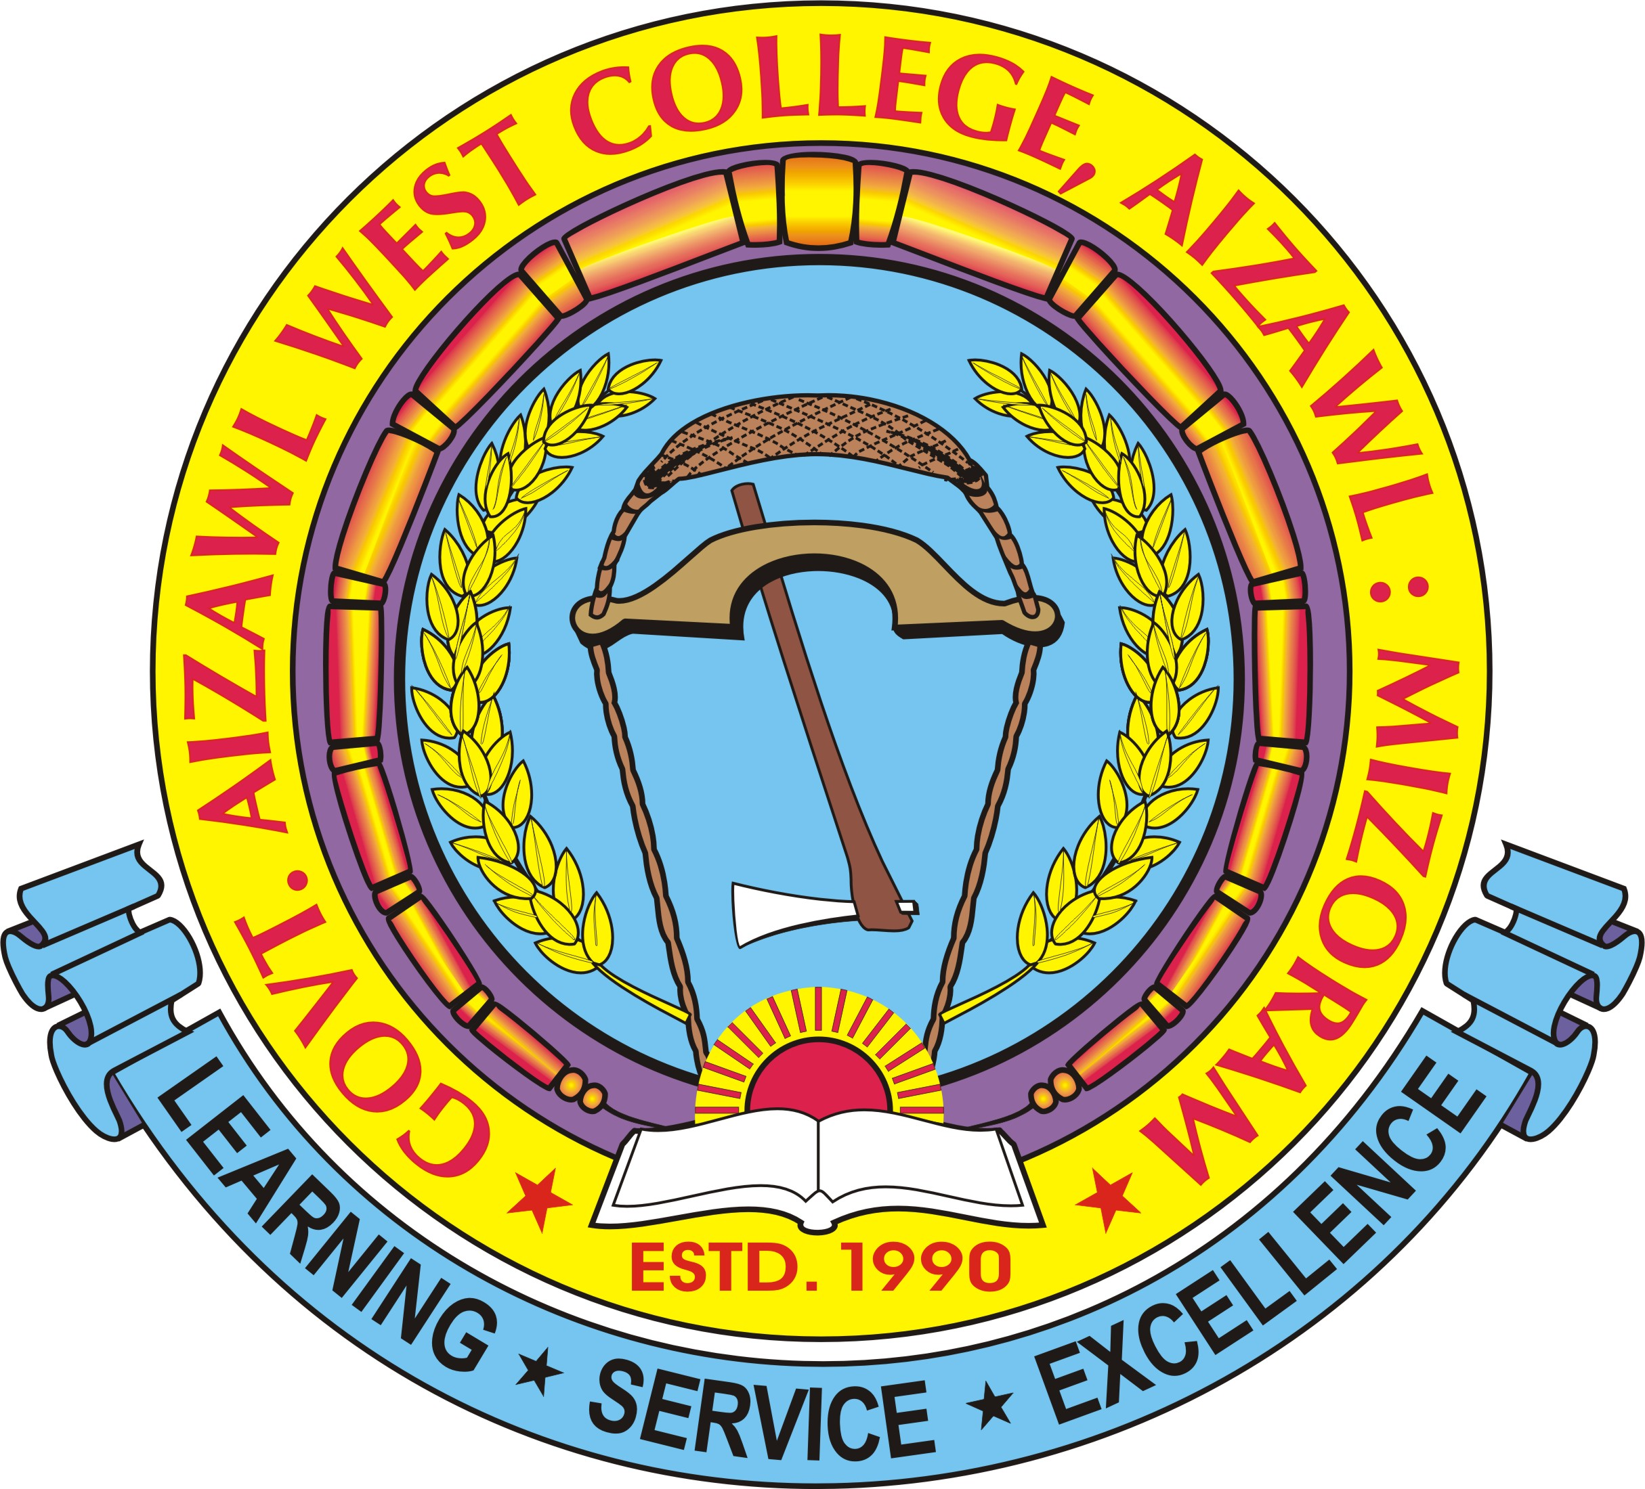
OFFICE OF THE PRINCIPAL
GOVT. AIZAWL WEST COLLEGE
GOVERNMENT OF MIZORAM
Dawrpui Vengthar, Aizawl, 796001 Ph – (0389) 2325945 (O) Fax – ( 0389 )- 2325945
No.B.18003/3/2009-GAWC/IQAC/ Dated Aizawl the 26th May, 2020

INTERNAL QUALITY ASSURANCE CELL (IQAC)
GOVT. AIZAWL WEST COLLEGE

NOTICE

This is to notify that different cells under IQAC have been restructured for the year 2020-2021.

- Steering Committee
Chairman : Prof. C. Lalthlengliana
Coordinator : Dr. Lalremruati
Asst. Coordinator : 1. Prof. Benjamin Lalrinsanga
: 2. Dr. Samuel V.L. Thlanga
Members
Ms. Lianhlupuii
Dr. P.L. Ramliana, RUSA – Co-Ordinator
Dr. Mary Ann Lalbiakhlui Zadeng
Mr. H. Lalvulliana
Dr. Janet Vanlalhlimpuii
Ms. Lalnunthari, AISHE - Co-Ordinator
Head Assistant
Mr. Lalhmingliana, UDC
Jt. Director, H&TE Govt. of Mizoram (Management representative)
Chairman, Local Council, Dawrpui Vengthar (Local representative)
Prof. Lalnundanga, MZU
Prof. H.K. Laldinpuii Fente, MZU
Vice President, Student’s Union GAWC

- Information Technology Cell
Chairman : Prof. Benjamin Lalrinsanga
Coordinator : Mr. V. Zothankhuma
Members
Mr. Lalhriata
Dr. Janet Vanlalhlimpuii
Dr. R. Lalsangpuii
Mr. H. Lalawmpuia

- Academic Interaction Cell
Chairman : Dr. Lalzawnga
Coordinator : Dr. Samuel VL Thlanga
Members
Dr. Mary Ann Lalbiakhlui Zadeng
Dr. Lalrohlui

- Research Project & Documentation Cell

Chairman : Dr. P.L. Ramliana
Coordinator : Dr. Janet Vanlalhlimpuii
Members
Dr. R. Lalzawnga
Prof. Benjamin Lalrinsanga
Ms. Lallianzuali Varte
Dr. Lalremruati Pachuau
Dr. Lianhmingthanga

- Grievance Redressal Committee
Coordinator : Dr. Rosangliani
Members
Ms. Lianhlupuii
Dr. Vanlalvena Hnamte
Ms. K. Lalmuanpuii
Dr. Lalremruati Pachuau
Ms. Lalrinkimi Khiangte

- Career & Placement Cell
Chairman : Ms. Vanchhingpuii
Coordinator : Ms. Lalnunthari
Members
Mr. Lalhriata
Dr. Vanlalvena Hnamte
Ms. Lalremruati Vanchhawng

- Counselling Cell
Chairman : Mr. Vanlalsawma
Coordinator : Dr. Lalrohlui
Members
Ms. Malsawmtluangi Chuauhang
Ms. Lalnunthari
Dr. Lalremruati Zote
Dr. Lalremruati Pachuau

- Language Development Cell
Chairman : Dr. Mary Ann Lalbiakhlui Zadeng
Coordinator : Ms. Lallianzuali Varte
Members
Ms. Vanchhingpuii
Mr. Lalhriata
Mr. Lalengzauva
Ms. Jennifer Saizamliani
Ms. Phillia L. Khiangte

- Sports & Youth Activities Cell
Chairman : Dr. Vanlalvena Hnamte
Coordinator : Mr. V. Zothankhuma
Members
Mr. Lalengzauva
Ms. Jennifer Saizamliani
Ms. Lalsangpuii
Teacher i/c Games & Sport
Vice President, S.U.
Gen. Secretary, S.U.
Secretary, Games & Sport, S.U.

- Internal Complaint Cell
Chairman : Ms. Lalrosangi
Coordinator : Ms. Jennifer Saizamliani
Members
Ms. Lianhlupuii
Dr. Lalrohlui
Three student’s representatives
Two Non-teaching staff
One NGO member

- Library & Information Cell
Chairman : Prof. C. Lalthlengliana, Principal
Coordinator : Librarian
Members
All Heads of Department
Dr. Lalremruati Zote, Co-Ordinator, IQAC
Vice President, S.U.

- Equal Opportunity Cell
Chairman : Prof. C. Lalthlengliana, Principal
Coordinator : Prof. Benjamin Lalrinsanga
Members
Dr. Lalremruati Zote
Dr. Vanlalvena Hnamte
Ms. Lalnunthari

- Anti-Ragging Squad
Chairman : Ms. K. Lalmuanpuii
Coordinator : Ms. Malsawmtluangi Chuauhang
Members
Mr. H. Lalvulliana
Dr. P.L. Ramliana
Dr. Janet Vanlalhlimpuii

- Mentoring Cell
Chairman : Mr. H. Lalvulliana
Coordinator : Dr. Lalremruati Pachuau
Members
Mr. Vanlalsawma
Dr. Lalremruati Zote

- Skill Development Cell
Chairman : Ms. Lianhlupuii
Coordinator : Dr. R. Lalsangpuii
Members
Prof. Benjamin Lalrinsanga
Dr. Lianhmingthanga

- Adventure Club
Chairman : Mr. Lalengzauva
Coordinator : Mr. V. Zothankhuma
Memmbers
Ms. Jennifer Saizamliani
Ms. Lalsangpuii
Leader, Adventure Club
Secretary, Adventure Club

- Cultural Club
Chairman : Ms. Lalthlamuanpuii
Coordinator : Ms. Lalremruati Vanchhawng
Members
Dr. Rosangliani
Mr. Lalengzauva
Ms. Lalsangpuii
Secretary, Social & Culture, S.U.

Sd/- Prof. C. LALTHLENGLIANA
Principal
Govt. Aizawl West College

Memo No.B.18003/3/2009-GAWC/IQAC/ Dated Aizawl the 26th May, 2020

Copy to –

1. The Joint Director (QAC), Higher & Technical Education, Mizoram – for information
2. All members for information and necessary action.
3. Office File.

(PROF. C. LALTHLENGLIANA)
Principal
Govt. Aizawl West College

